Prediction of Parkinson’s Disease Using Speech Signals

*P. Deepa 1, C. Harshini2, S. Keerthika3, B.D. Madhumitha4*

*1Associate Professor,2,3,4 UG Students,*

*1,2,3,4Department of CSE, Panimalar Engineering College*, *Chennai, India*.

[*finalyear04@gmail.com.*](mailto:finalyear04@gmail.com)

*Abstract*— Parkinson Disease (PD) is a neurodegenerative dis- order. Numerous common symptoms which may or may not indicate that case is suffering from Parkinson Disease. In this study a new standing scale has been introduced which helps to examine the position of Parkinson Disease but isn't obligatory that a person having analogous symptoms may surely suffer from Parkinson Disease. PD is an unsolved problem till date hence the study focuses on applicable features, medicines and common ways used to descry or dissect PD. To overcome similar problem different ways will be used to study and dissect the early discovery of PD. It can be anatomized with the help of deep understanding of Parkinson Disease. Still presence of some common symptoms has not yet been described up to the mark to dissect the position of Parkinson Disease. Hence, it's veritably grueling to descry early stage of Parkinson Disease. In study, work focuses on only verified symptoms of Parkinson Disease which doesn’t deals to any other disease fully.

*Index Terms*—Parkinson’s Disease Detection, Different techniques to analyze Parkinson Disease, Vocal features, Speech Signals, Deep learning algorithm, PD classification.

**I.INTRODUCTION**

Neurodegenerative disorder is a disease that results in the illness and damage to some parts of brain. It can be cured up to some extent. The patient suffering from neurodegenerative disorder may be recovered grounded on the stage under which case is suffering. Neurodegenerative disorder occurs when the nerve cells get damaged and indecorous signaling cause detention in the movement.

Parkinson’s Disease (PD) is a progressive neurodegenerative disorder of high frequencies rate, with 1 percent of people above the age of 60 being affected. PD substantially impacts people over 50 years old and, considering the continuously growing population, the number of affected individualities will only increase. The reduction of dopaminergic neurons in the substantia nigra and the presence of Lewy bodies and accumulations of nascence-synuclein protein are the main pathological emblems of PD. PD manifests with motor symptoms, including earthquake, bradykinesia, muscle severity and speech impairment, as well as non-motor signs, i.e., sleep diseases, cognitive impairment and constipation. Timely Opinion of PD is frequently delayed, since symptoms are subtle at the early stages and their assessment generally requires an in- clinic evaluation of the subject’s condition by a movement diseases expert. Overall, the standard medical practice regarding PD opinion is of private nature; its effectiveness depends on times.

The speech defects that PD causes correspond of reduced intensity of voice, monopitch and incorrect articulation of consonants, among several others. moreover, of PD cases face voice impairment. This has made the auditory analysis of speech signals for early PD discovery a ferocious investigation area. Former methodologies have primarily concentrated on the oral impairment estimation using Sustained vowel phonations. Running speech analysis from data (155 PD and 150 HC) captured in-the- clinic has demonstrated a performance of 98 precision for PD cases classification versus HC. The features used relate with the oral fold vibration changes seen between voice (i.e., shaking Oral folds) and unspoken (i.e., on- vibrating oral folds) sounds, as reflected in the voice frequencies content. The strong investigation beneficence on the field and the high precision results presented so far in the lab- setting is a solid stepping gravestone towards a remote speech- based PD marker. Still, reaching to the ecologically valid capturing of oral defects caused by PD in running- speech across different speaking languages, genders and eras make the running speech analysis challenging in a real-life PD detection scenario.

There's generally a pronounced effect on speech,

including hypophonia (lowered volume), and monotone (reduced pitch range). Also, cognitive impairments and changes in mood can do, and threat of madness is increased. Traditional opinion of Parkinson’s disease involves a clinician taking a neurological history of the case and observing motor skills in various situations. Since there's no definitive laboratory test to diagnose PD, opinion is frequently delicate, particularly in the early stages when motor movements aren't yet severe. Monitoring progression of the disease over time requires repeated clinic visits by the patients. An effective screening process, particularly one that doesn’t require a clinic visit, would be salutary. Since PD cases have characteristic oral features, voice recordings are a useful and non- invasive tool for opinion. Still, this would be an effective screening step prior to an appointment with a clinician, If deep learning algorithms could be applied to a voice recording dataset to directly opinion PD. The once dataset is collected and that dataset is used to make a deep learning model. The data is imaged for better understanding of the features and based on that a classification model is erected by using deep learning.

1. **LITERATURE SURVEY**

A lot of research has been done to predict Parkinson’s disease in a patient, but less work has been reported to predict its severity. These works have used various machine learning techniques, deep learning techniques and various other techniques to predict the Parkinson disease. In a survey by Christos Laganas.[1] on the Parkinson’s Disease Detection Based on Running Speech Data from Phone Calls, a machine learning-based approach was considered to be the better approach for voice-based smartphone data from subjects’ running speech recordings are used for predicting the PD severity. Apoorva Safai.[2] on Multi-modal brain-based prediction of Parkinson disease using Graph Attention Networks, GAT (GRAPH ATTENTION NETWORK) model which is used to generate node embeddings from the structural connectivity matrix and multimodal feature. PubMed Journal.[3] on Vocal Feature Extraction based Artificial Intelligence model for Parkinson disease detection, two hybrid models based on SVM integrating with principal component analysis and a sparse auto-encoder are proposed based on vocal features for the detection of the Parkinson disease. Anusri [4] on An Early Prediction of Parkinson’s disease using facial emotional Recognition, where facial emotions are classified using CNN architecture for the detection of Parkinson disease. Ahlem Kehili.[5] on Early Parkinson detection using fully connected deep neural network based on vocal features, vocal features were proposed using fully connected deep neural network as a classifier to detect Parkinson disease in person. Srivardhini Veeraragavan.[6] on Parkinson’s Disease Diagnosis and Severity Assessment Using Ground Reaction Forces and Neural Networks, in which Gait features are extracted and selected to use as training features for the Artificial Neural Network (ANN) model to diagnose PD using cross validation. F.M. Javed Mehedi Shamrat.[7] on A Comparative Analysis of Parkinson Disease Prediction Using Machine Learning Approaches, in which AI methods are used for the detection of Parkinson disease datasets using SVM, KNN, and LR. Amit Kumar Patra.[8] on Prediction of Parkinson’s disease using Ensemble Machine Learning classification from acoustic analysis, Decision Trees, Logistic Regression and K-nearest neighbors’ techniques are used for the detection of the Parkinson disease. David J. Brooks.[9] on Imaging Approaches to Parkinson Disease, in which Structural changes in PD nigra can be detected with both transcranial sonography and diffusion tensor MRI. Srishti Grover.[10] on Predicting severity of Parkinson disease using deep learning, prediction of the Parkinson disease is performed using the deep learning technique in which the collected data is normalized using min-max normalization.

**III. PROPOSED METHODOLOGY**

The proposed methodology for prognosticating the Parkinson’s disorder rigorousness using deep learning. In first step, the voice data of PD cases is collected for analysis. Also, the collected data is formalized using min- max normalization. In the following step deep, neural network is designed with input level, isolated layers and output level. The number of neurons in the input level is fixed as the number of attributes in the input data. The output level contains two neurons corresponds to the three classes – “Parkinson”, “mild-Parkinson” and “healthy”. The formalized data is fed into the constructed deep neural network for training and testing.

In this Paper, a Deep learning- based approach for voice-based data from subjects’ running speech recordings is discussed. These show that PD can be detected from voice recordings and features that were previously validated. since, subjects were clinically examined, showing that the uprooted criteria can distinguish the early PD from the healthy controls and can be further used in the everyday life for the monitoring of voice deterioration. Used for evaluation and monitoring of motor impairments in PD cases through task- based speech, gait and hand movements. Primary results show that utmost of the estimated features indicate significant differences between PD cases and healthy controls, paving the way for additional investigation of voice- based operations in evaluation of PD.

These reports are to the examination of relevance of deep learning ways for Parkinson disorder prognostication in functional conditions. Finally, it highlights some observations on future investigation issues, challenges, and needs. We're prognosticating the Parkinson disorder prognostication using Multi-Dimensional Voice Program data with auditory parameters. We going to Deploy Deep Learning Model as Web Application. Accuracy, Recall F1 score criteria are Calculated.

# SYSTEM ARCHITECTURE

# Initially voice dataset from Kaggle is collected and voice dataset is preprocessed where audio signal is converted into digital signal. Features are extracted from the preprocessed data and model is trained. The trained model is fed to the CNN algorithm to test. When the user provides the audio signal, data is preprocessed, features are extracted and is fed to the CNN algorithm, and the finally the algorithm predicts the health status of the person as either Parkinson or mild Parkinson or healthy.

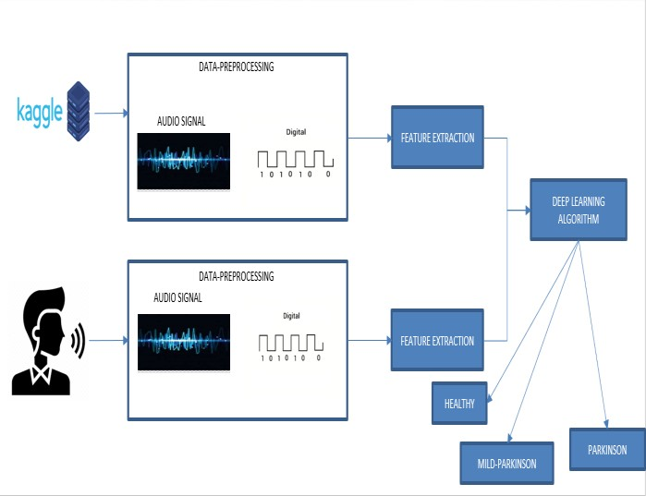

**III.MODULE DESCRIPTION**

**DATA PREPROCESSING**

In this project, a primary microphone is used through which the users voice is recorded. The Recorded voice signal obtained from the users is converted from analog to digital signal. The mean value of the digital signal is converted into numerical array. Further, this numerical array is converted and reshaped for the correct fitting for the predicting.

**FEATURE EXTRACTION**

Features are extracted from the preprocessed data. From the audio wave signal obtained, LSTM dense, dropout, activation layers are extracted from higher and lower dimensions. Finally, all these extracted layers are fed into a model and the model is configured for training. The model is compiled with parameters called loss, optimizers and metrics.

**CLASSIFICATION**

Based on the feature selection which is done prior to classification, the cases are classified as Healthy, Mild Parkinson disorder and Parkinson disorder.

**TRAINING**

The voice dataset of Parkinson affected person and healthy person is collected from Kaggle. The collected voice dataset is preprocessed and features like frequency, amplitude are extracted. Based on the features extracted the model is trained

**TESTING**

The voice of the user is collected from user interface. The collected voice is preprocessed and required features like are extracted from the voice. Based on the modeled data, the system extracts the features and predicts the status of person such as Healthy, Mild Parkinson and Parkinson

**ALGORITHM**

**STEP 1:** The Audio signal received from the user is converted into digital signal using data pre-processing where the mean value of the digital signal is converted into numerical array.

**STEP 2:** Further, this numerical array is reshaped for the correct fitting for the prediction.

**STEP 3:** Once the data is pre-processed, the feature extraction takes place where from the audio wave signal obtained, LSTM dense, dropout, activation layers are extracted from higher and lower dimensions.

**STEP 4:** Finally, all these extracted layers are fed into a model and the model is configured for training.

**STEP 5:** The model is compiled with parameters called loss, optimizers and metrics.

**STEP 6:** At last, the compiled model is returned to be used in the algorithm.

**STEP 7:** Based on the CNN trained model, the system tests the feature extracted and predicts the health status of person such as Healthy, Mild Parkinson and Parkinson**.**

**IV.RESULTS AND DISCUSSION**

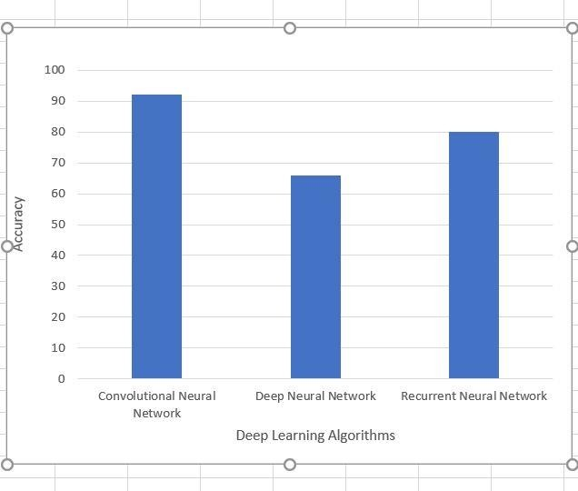The Developed models were used to detect PD disorder patients. For the experiment, the dataset mentioned earlier was used to evaluate the model performance to find out the best one, and comparisons with CNN, DNN and RNN were exhibited. The dataset was split into 70% and 30% for training and test purposes, respectively, with no subject occurring in the test or train data simultaneously. For the results of different performances obtained with the tested classifiers and using all vocal features in the dataset, CNN classifier has achieved the best performances in terms of all metrics when compared to other two algorithms. When Audio input is uploaded the accuracies and predictions.Obtained are (CNN: Normal, Accuracy=0.95 DNN: Parkinson, Accuracy=0.81 RNN: Parkinson, Accuracy=0.42).

**Accuracy analysis when audio file is uploaded**

|  |  |  |
| --- | --- | --- |
| SNO | ALGORIHTM | ACCURACY |
| 1 | CNN | 0.85 |
| 2 | DNN | 0.40 |
| 3 | RNN | 0.70 |

**Accuracy analysis when real time audio is provided**

|  |  |  |
| --- | --- | --- |
| SNO | ALGORIHTM | ACCURACY |
| 1 | CNN | 0.85 |
| 2 | DNN | 0.40 |
| 3 | RNN | 0.70 |

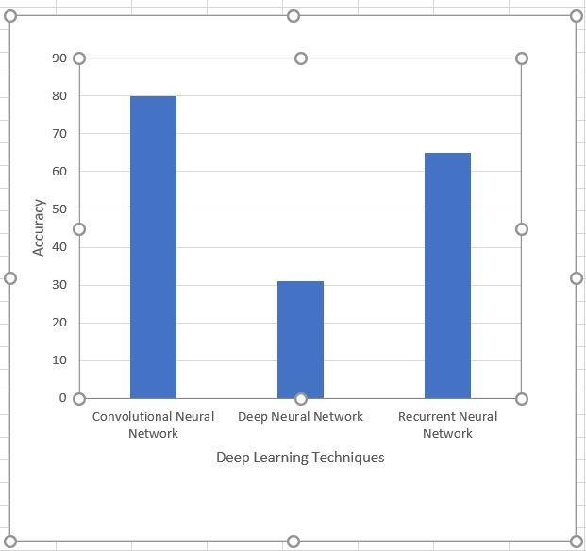

**V.CONCLUSION**

In this paper, we've represented three Deep learning approaches. A while after, the performance of the three approaches which are applied in the prognostication of Parkinson disorder. The conditional performance demonstrations that the CNN has achieved the topmost performance than the other two deep learning approaches within the Parkinson datasets. This analysis has applied three deep learning methodologies for the exposure of Parkinson disorder in view of some parameters. In accumulation, this work is part of a design that has the goal to cultivate an automated operation to give more accurate action to normal incidents and make a superior decision to multifaceted situations. The operation will be suitable to discover in Parkinson disorder in actually some flashes and notify the dangerous probability of having the disorder. This operation can be outstandingly profitable to people, where is a lack of medical attention and as well as particular physicians. In tests, each algorithm was prepared and assessed on a training set that includes healthy, mild-Parkinson and Parkinson samples. Also, the work can be confirming of Parkinson disorder detection by collecting data from different speech signal and voice datasets and can give more accurate results for disorder prognostication and decision. We've only researched three algorithms; it can be preferring further algorithms for developing the precise model of these Parkinson disorder prognostication and performance can be more advanced. In synopsis, our study painted the exploration aim besides occasion with respect to Parkinson disorder area by deep learning approaches, which has an arising benefit in health fields

# VI.REFEENCES

# Christos Laganas, Dimitrios Iakovakis, Stelios Hadjidimitriou, Vasileios Charisis, Sofia B. Dias, Sevasti Bostantzopoulou, Zoe Katsarou, Lisa Klingelhoefer, Heinz Reichmann, Dhaval Trivedi, K. Ray Chaudhuri, and Leontios J.Hadjileontiadis, Senior Member, IEEE(2021) “*Parkinson’s Disease Detection Based on Running Speech Data From Phone Calls”,* IEEE Transactions on Biomedical Engineering : DOI 10.1109/TBME.2021.3116935,

# <https://ieeexplore.ieee.org/stamp/stamp.jsp?arnumber=9556632>

# Ahlem Kehili, dabbabi Karim, Cherif Adnen (2020) “*Early Parkinson Detection Using Fully-Connected Deep Neural Network based on Vocal Features “ ,*IJCSNS International Journal of Computer science and Network Security , University of Tunis , VOL.20 N0.6 June 2020

# <https://www.researchgate.net/publication/343100129_Early_Parkinson_Detection_Using_Fully-Connected_Deep_Neural_Network_based_on_Vocal_Features>

# J. Sujatha, Dr . S.P. Rajagopalan(2017), “*Performance Evaluation of Machine Learning Algorithms in the Classification of Parkinson Disease Using Voice Attributes “,* International Journal of Applied Engineering Research , India : ISSN 0973-4562 Volume 12, Number 21

# <http://www.ripublication.com/ijaer17/ijaerv12n21_24.pdf>

# Srishti Grover, Saloni Bhartia, Akshama, Abhilasha Yadav, Seeja K.R(2018), “*Predicting Severity Of Parkinson’s Disease Using Deep Learning”,*International conference on Computational Intelligence and Data ,Department of Computer Science and Engineering Indira Gandhi Delhi Technical University for Women, Kashmere Gate, Delhi, 110006, India, Procedia Computer Science Volume 132 , Pages 1788-1794,2018

# https://[www.sciencedirect.com/science/article/pii/S1877050918308883](https://www.sciencedirect.com/science/article/pii/S1877050918308883)

# Shubham Bind , Arvind Kumar Tiwari , Anil Kumar Sahani(2015),” *A Survey of Machine Learning Based Approaches for Parkinson Disease Prediction”* (IJCSIT) International Journal of Computer Science and Information Technologies, Department of CSE, KIT, Department of CSE, IIT (BHU) Varanasi, India , Vol. 6 (2) , 2015, 1648-1655

# <https://citeseerx.ist.psu.edu/viewdoc/download?doi=10.1.1.735.5660&rep=rep1&type=pdf>

# Amit Kumar Patra , Ratula Ray, Azian Azamimi Abdullah, Satya Ranjan Dash(2019),” *Prediction of Parkinson's disease using Ensemble Machine Learning classification from acoustic analysis “,* Journal of Physics: Conference Series, IOP publications , UK, Volume : 1372, NO:1742-6596/1372/1/012041

# <https://iopscience.iop.org/article/10.1088/1742-6596/1372/1/012041/pdf>

# Apoorva Safai, Nirvi Vakharia, Shweta Prasad, Jitender Saini, Apurva Shah, Abhishek Lenka, Pramod Kumar Pal, and Madhura*,” Multi-modal brain based prediction of Parkinson disease using Graph Attention Networks”,* Researchgate, Volume : 15 , article :748414

# <https://www.researchgate.net/publication/358798991_Multimodal_Brain_Connectomics-Based_Prediction_of_Parkinson's_Disease_Using_Graph_Attention_Networks>

# F.M. Javed Mehedi Shamrat, Md. Asaduzzaman(2019),” *A Comparative Analysis Of Parkinson Disease Prediction Using Machine Learning Approaches”,* International Journal of Scientific and technology research, VOLUME 8, ISSUE 11, PN.NO – 2576-2580

# https://[www.researchgate.net/publication/338924577_A_Comparative_Analysis_Of_Parkinson_Disease_Prediction_Using_Machine_Learning_Approaches](https://www.researchgate.net/publication/338924577_A_Comparative_Analysis_Of_Parkinson_Disease_Prediction_Using_Machine_Learning_Approaches)

# Muntasir Hoq , Mohammed Nazim Uddin , Seung-Bo Park(2021),” Vocal Feature Extraction based Artificial Intelligence model for Parkinson disease detection”,Pubmet, 2021 Jun 11 (6):1076. doi: 10.3390/diagnostics11061076.

# <https>[://pubmed.ncbi.nlm.nih.gov/34208330/](https://pubmed.ncbi.nlm.nih.gov/34208330/)

# U Anusri, G Dhatchayani, Y Princely Angelinal and S. Kamalraj(2021) “An Early Prediction of Parkinson’s disease using facial emotional Recognition.”, Journal of Physics 2021 J.Conf. Ser. 1937 012058

# <https>[://iopscience.iop.org/article/10.1088/1742-6596/1937/1/012058](https://iopscience.iop.org/article/10.1088/1742-6596/1937/1/012058)